Authentication and Access Control
Q1. Create a simple login form for a mock Zomato admin panel that asks for username and password, then displays 'Access Granted' only if both fields match hardcoded admin credentials.
Ans:
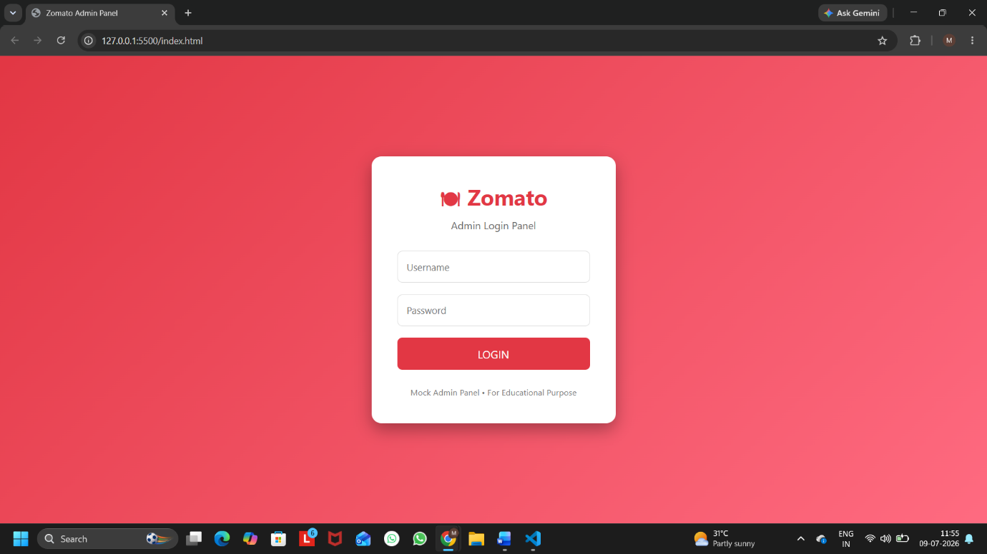
Figure 1: Zomato Admin Login Page
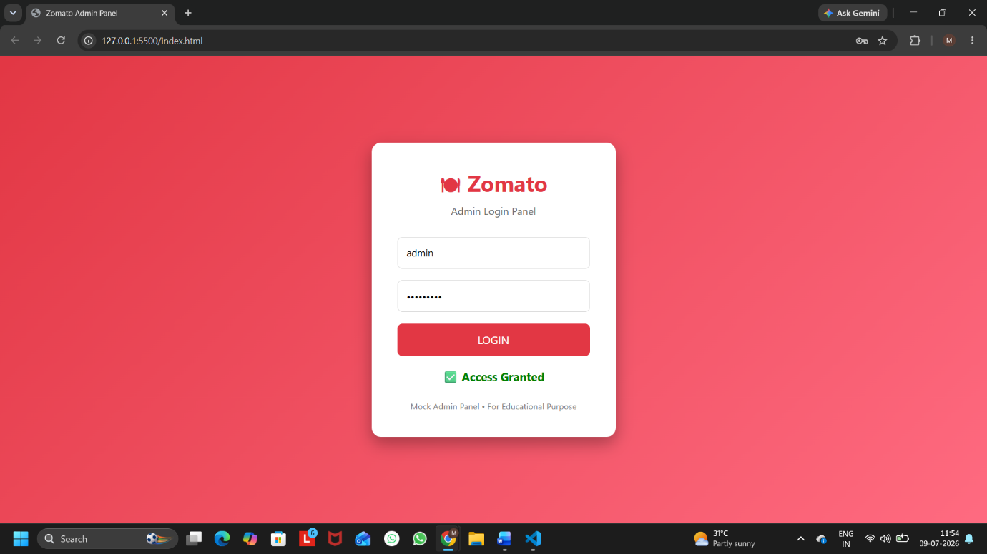
Figure 2: Successful Login Using Hardcoded Credentials
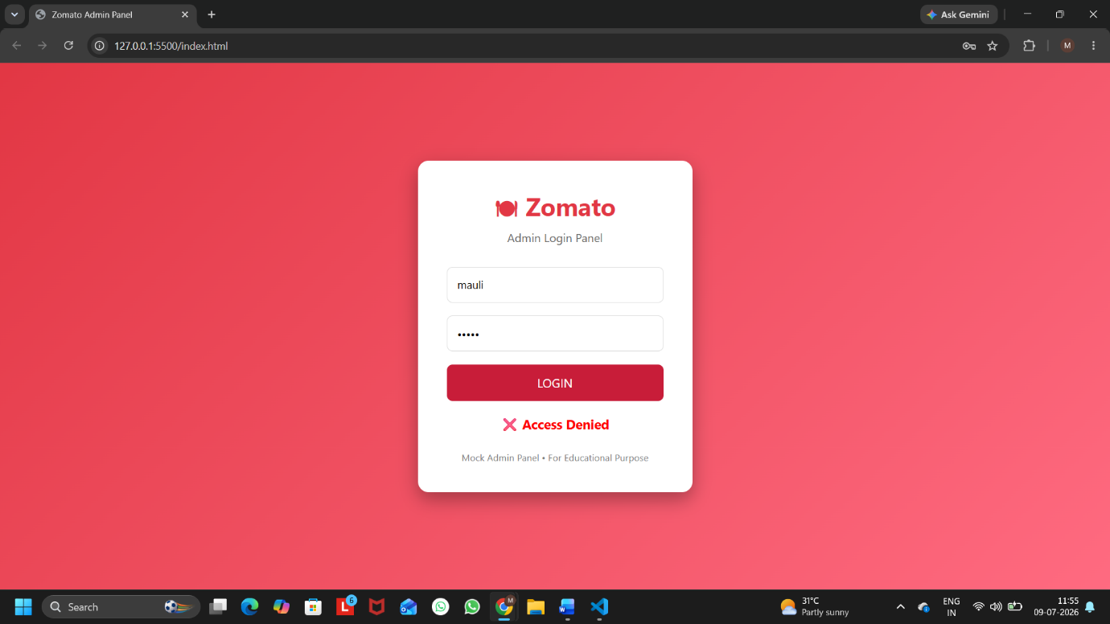
Figure 3: Invalid Login Attempt
Procedure:
- Created a login page with Username and Password fields.
- Added a Login button.
- Stored the hardcoded credentials (admin and zomato123) in JavaScript.
- Compared the entered username and password with the stored credentials.
- Displayed "Access Granted" if the credentials matched; otherwise displayed "Access Denied".
Result:
The login form successfully authenticated users based on the hardcoded credentials and displayed the appropriate login status.

Q2. Write a Python function check_access(user_role, resource) that returns True if the user_role is allowed to access the resource, otherwise False. Test it with roles like 'customer', 'restaurant_owner', and resources like 'menu_edit', 'order_history', 'admin_dashboard'.<br><br><em><strong>Hint:</strong> Use a dictionary to map roles to allowed resources.</em>
Ans:
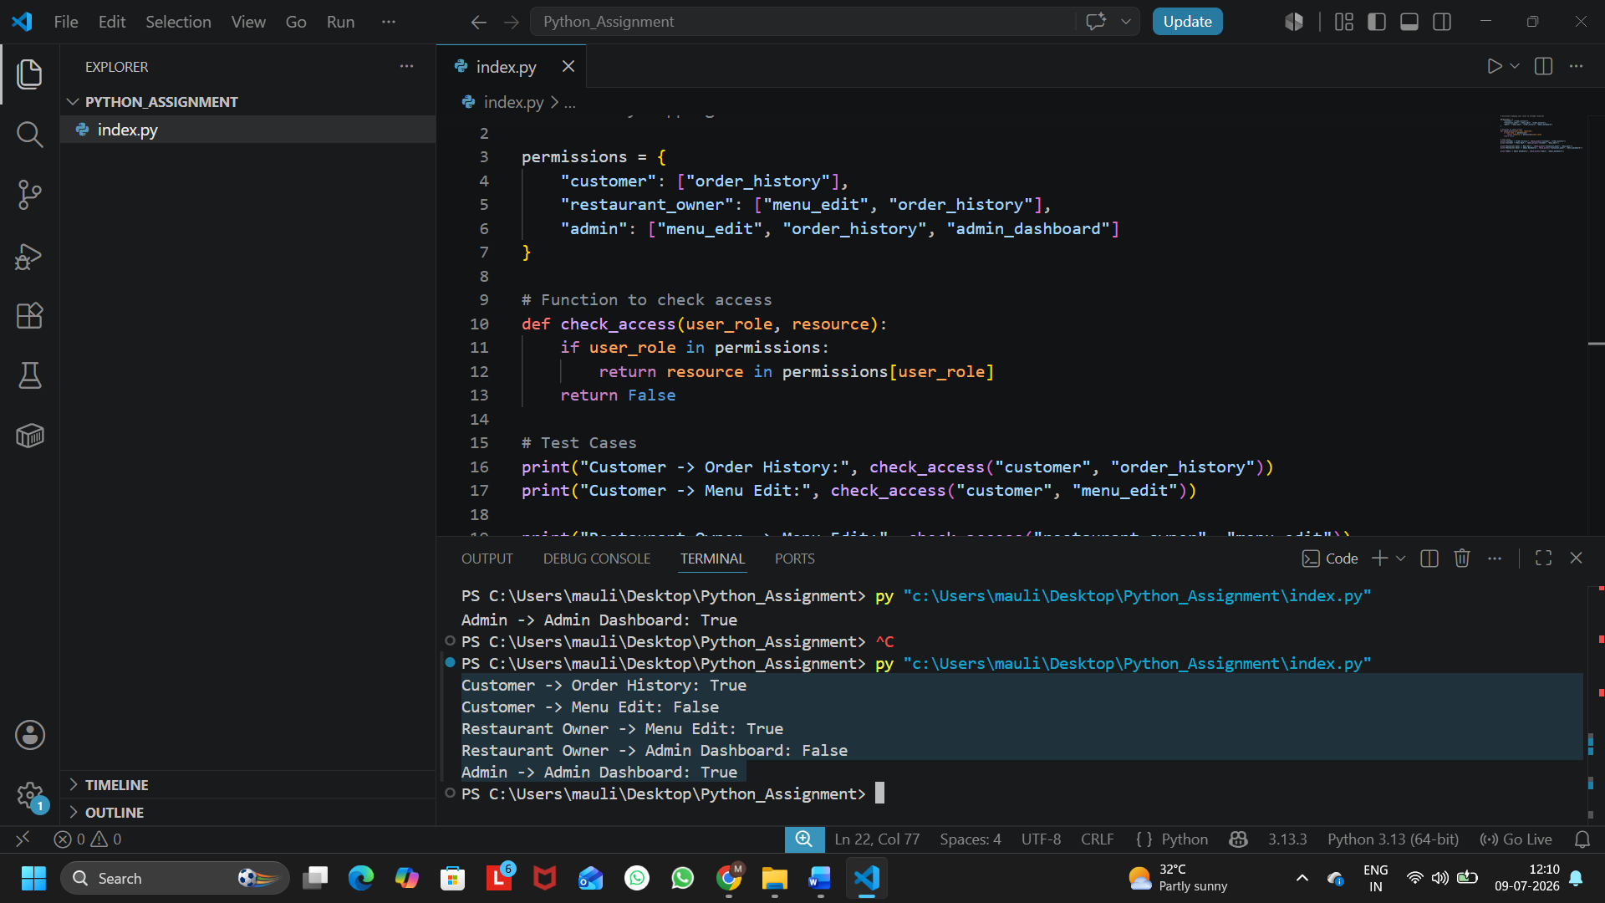
Figure 1: Output of Python Role-Based Access Control Program

# Dictionary mapping user roles to allowed resources
permissions = {
"customer": ["order_history"],
"restaurant_owner": ["menu_edit", "order_history"],
"admin": ["menu_edit", "order_history", "admin_dashboard"]
}
# Function to check access
def check_access(user_role, resource):
if user_role in permissions:
return resource in permissions[user_role]
return False
# Test Cases
print("Customer -> Order History:", check_access("customer", "order_history"))
print("Customer -> Menu Edit:", check_access("customer", "menu_edit"))
print("Restaurant Owner -> Menu Edit:", check_access("restaurant_owner", "menu_edit"))
print("Restaurant Owner -> Admin Dashboard:", check_access("restaurant_owner", "admin_dashboard"))
print("Admin -> Admin Dashboard:", check_access("admin", "admin_dashboard"))

User Role | Resource | Output | Reason
customer | order_history | True | The customer is allowed to view their own order history.
customer | menu_edit | False | Customers are not permitted to edit the restaurant menu.
restaurant_owner | menu_edit | True | The restaurant owner has permission to edit the menu.
restaurant_owner | admin_dashboard | False | The admin dashboard can only be accessed by the administrator.
admin | admin_dashboard | True | The administrator has full access to the admin dashboard.

Q3 Simulate a two-factor authentication flow like Paytm: after a user enters the correct password, generate a 6-digit OTP and display it in the console. Ask the user to input the OTP and display 'Login Successful' only if it matches.
Ans:
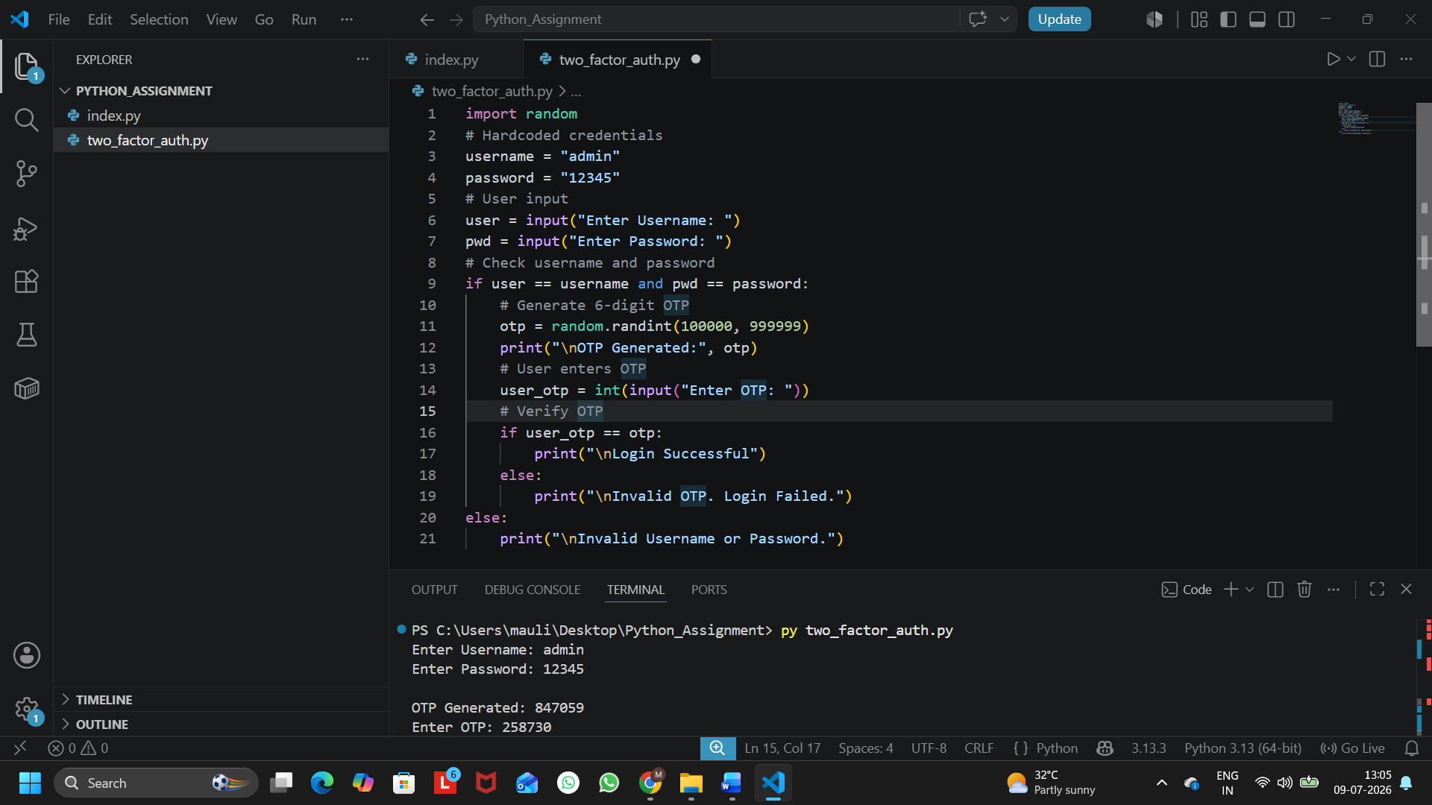
Figure 1: Python Program Code (Screenshot)

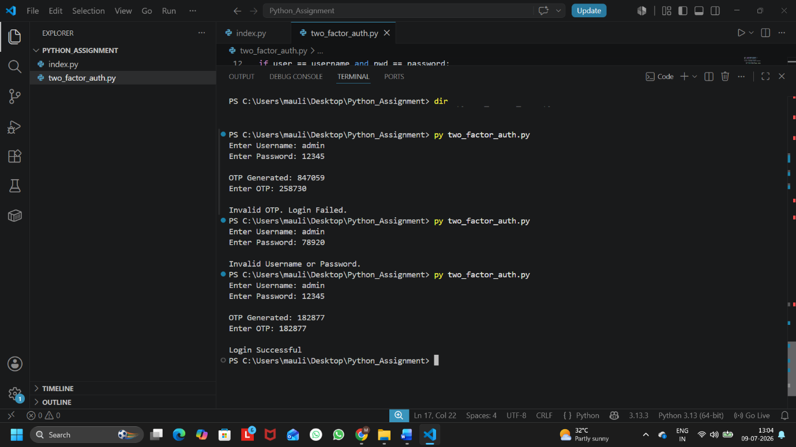
Figure 2: Program Output (Screenshot)

Q4.Given an array of user objects with properties: username, isPremium, and lastLogin, write a function that returns only those users who are premium and have logged in within the last 7 days.<br><br><em><strong>Constraint:</strong> Assume lastLogin is a date string in 'YYYY-MM-DD' format, and today is '2024-06-10'.</em>
Ans:
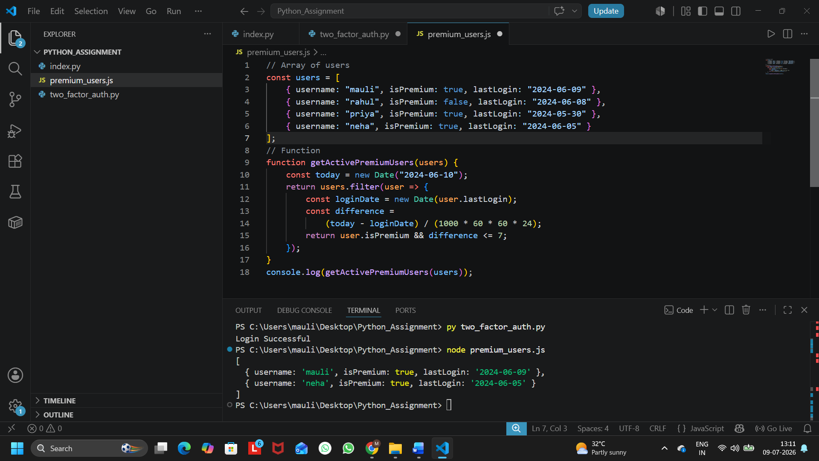
Figure 1: Output of Premium User Filtering Program

Q5. Use ChatGPT to generate a list of 5 common access control mistakes developers make in real-world apps like Instagram or Flipkart, and for each, write a one-line fix or prevention tip.
Ans:
Access Control Mistake | One-Line Fix / Prevention Tip
1. Weak or predictable passwords | Enforce strong passwords and use password complexity rules.
2. Missing Role-Based Access Control (RBAC) | Allow users to access only the features permitted for their role.
3. No Multi-Factor Authentication (MFA) | Enable OTP or authenticator-based two-factor authentication for login.
4. Exposing admin pages without authorization | Verify user permissions on the server before granting access to admin pages.
5. Keeping user sessions active for too long | Set session timeouts and automatically log users out after inactivity.

